**English, David J. (1000265992)**

**EE5322 – Intelligent Control Systems**

**Homework #1**

**23 January 2014**

**Problem 1**

(a.) 20-Day Moving Average and Stock Closing Price



(b.) Stock Minus the20-Day Moving Average



(c.) 20-Day Moving Sample Variance



(d.) Closing Price, 20-Day MA, and Bollinger Bands



**Problem 2**

(a.)20-Day Moving Skew



(b.) 20-Day Moving Kurtosis



(c.) Stock Trend Break Prediction: In order to help identify a leading indicator to predict movement in the stock I have plotted the moving variance, skew, and kurtosis on the same plot as the NVDA closing price and moving average.



Movements in the stock seem to be predicated by peaks in both the skew and kurtosis. However, it’s not clear how the peaks relate to the stock price going up or down. I thought it might be related to the direction of peaks, i.e. if skew and kurtosis go the same direction, the price will go up and vise versa for a dropping price. To test the theory I plotted the derivative of the skew multiplied by the derivative of the kurtosis. In order to easily make a comparison to the stock price on the same graph I also added in the 20-Day moving average.



The above graph seems to show the green line either has an increase or decrease in slope the day before the stock price increases or decreases. The two plots below zoom in for closer inspection.





Although the amplitude of the slope may not indicate how much the stock will rise or fall, this seems to be a somewhat effective predictor of stock movement.

**Problem 3**

(a.) Autocorrelation



(b.) Autocovariance



**Problem 4**

(a.) DFT of Entire Signal – Magnitude (loglog) and Phase (semilog)



Now, magnitude only on a semilog plot



(b.) DFT of (Entire Signal Minus the 20-Day Moving Average)



(c.) Time-Varying DFT with a 20-Day Moving Window

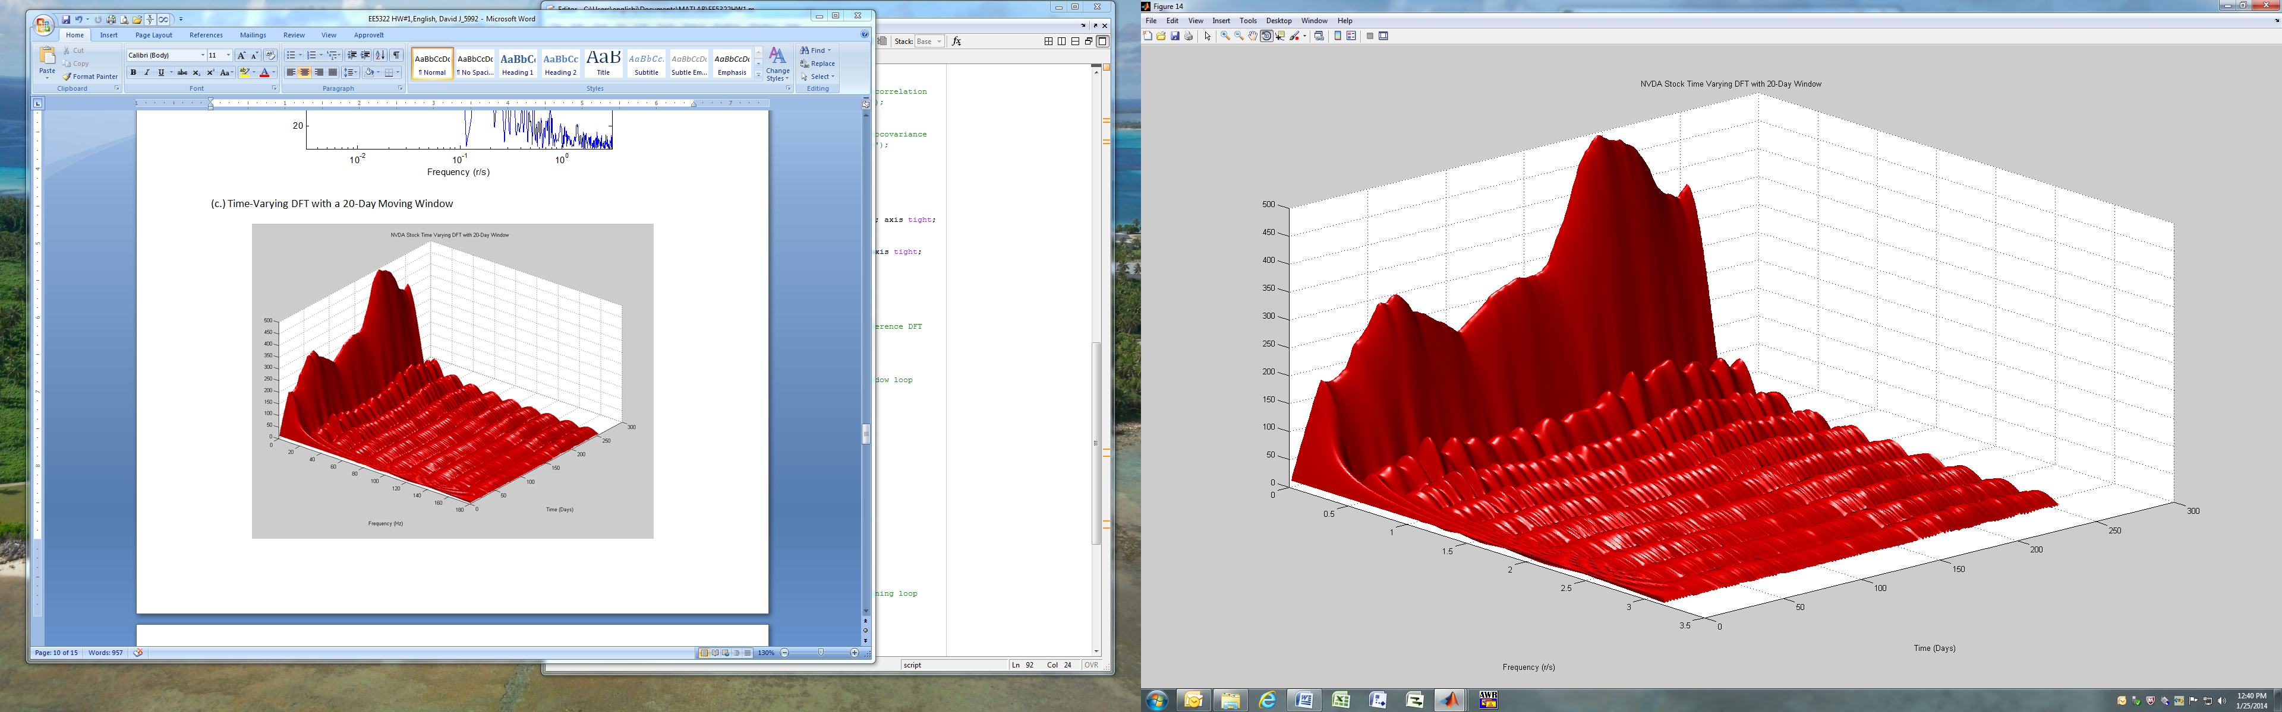

(d.) Time-Varying DFT with a Fixed, 20-Day Bins

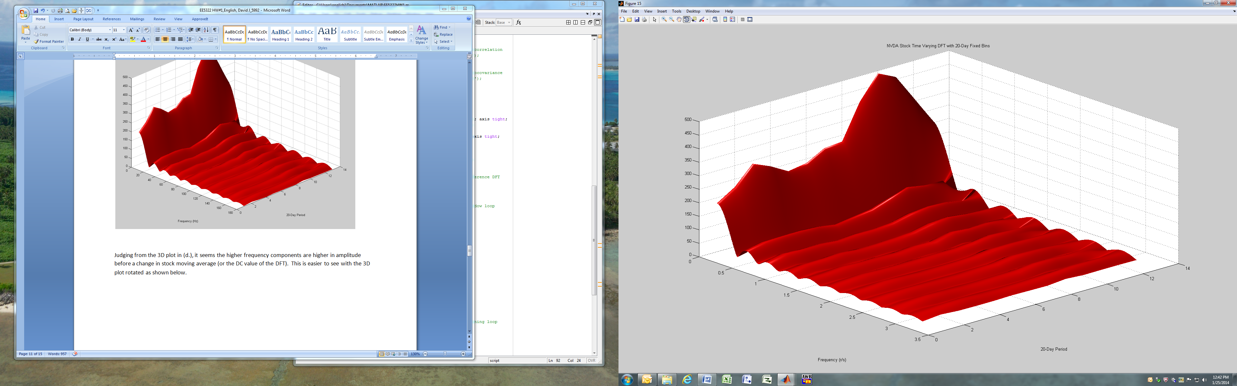

Judging from the 3D plot in (d.), it seems the higher frequency components are higher in amplitude before a change in stock moving average (or the DC value of the DFT). This is easier to see with the 3D plot rotated as shown below.

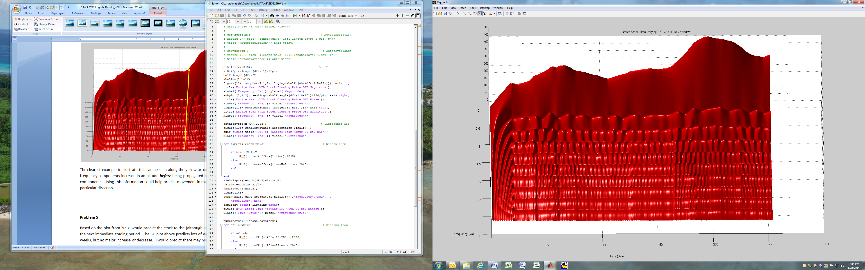

The clearest example to illustrate this can be seen along the yellow arrow in the plot above. The high frequency components increase in amplitude ***before*** being propagated to the lower frequency components. Using this information could help predict movement in the stock price, although not in a particular direction.

**Problem 5**

Based on the plot from 2(c.) I would predict the stock to rise (although I have no idea how much) during the next immediate trading period. The 3D plot above predicts lots of variation over the next several weeks, but no major increase or decrease. I would predict there may not be much use in buying or selling the stock over the next “moderate” time period.

Looking at NVDA historical data is looks like out data ends in early 2011. In the short time period after our data ends, the stock is indeed volatile, but the average pretty much stays the same. Shortly thereafter, however, the price of the stock has dropped and still has not recovered to the $20/share level.

**MATLAB Source Code**

% EE5322 - Intelligent Control Systems

% HW #1, Due 23 Jan 2014

% English, David J. (1000265992)

clear all;

load('data.mat'); days=data(:,1); x=data(:,2); % Load data

N=20; % Window size

for n=1:length(days) %Moving ave, Var, skew, kurtosis

if n-(N-1)<1

MA(n)=mean(x(1:n));

variance(n)=var(x(1:n));

skew(n)=skewness(x(1:n));

kurt(n)=kurtosis(x(1:n));

else

MA(n)=mean(x(n-N+1:n));

variance(n)=var(x(n-N+1:n));

skew(n)=skewness(x(n-N+1:n));

kurt(n)=kurtosis(x(n-N+1:n));

end

end

figure(1); plot(days,x,'b'); % Moving average plot

hold on; plot(days,MA,'r'); hold off;

title('NVDA Stock Price')

axis([0 254 0 35]); xlabel('Day'); ylabel('Stock Price $');

legend('Closing Price','20 Day Moving Average');

figure(2); plot(days,x-MA','b'); % Difference plot

title('NVDA Stock Price Minus 20 Day MA')

axis([0 254 -8 8]); xlabel('Day'); ylabel('Difference');

figure(3); plot(days,variance','b'); % Variance plot

title('NVDA Stock Price 20 Day Moving Variance')

axis([0 254 0 10]); xlabel('Day'); ylabel('Variance');

figure(4); plot(days,x,'b'); % Bollinger Plot

hold on; plot(days,MA,'r'); hold off;

hold on; plot(days,MA+3.*sqrt(variance),'k'); hold off;

hold on; plot(days,MA-3.*sqrt(variance),'k'); hold off;

title('NVDA Stock Price With Bollinger Bands')

axis([0 254 0 35]); xlabel('Day'); ylabel('Stock Price $');

legend('Closing Price','20 Day Moving Average','Bollinger Bands');

figure(5); plot(days,skew,'b'); % Skew plot

title('NVDA Stock Price 20 Day Moving Skew')

axis([0 254 -5 5]); xlabel('Day'); ylabel('Skew');

figure(6); plot(days,kurt,'b'); % Kurtosis plot

title('NVDA Stock Price 20 Day Moving Kurtosis')

axis([0 254 0 10]); xlabel('Day'); ylabel('Kurtosis');

figure(7); plot(days,x,'b'); % Break trend predict plot

hold on; plot(days,MA,'r'); hold off;

hold on; plot(days,variance,'k'); hold off;

hold on;plot(days,skew,'g'); hold off;

hold on;plot(days,kurt,'m'); hold off;

hold on;plot(10+diff(kurt).*diff(skew),'k'); hold off;

title('NVDA Stock Price 20 Day Moving Statistics');

legend('Closing Price','20 Day Moving Average','Variance'...

,'Skew','Kurtosis');

axis([0 254 -5 30]); xlabel('Day');

figure(8); plot(days,x,'bo-'); % Break trend predict plot 2

hold on; plot(days,MA,'r'); hold off;

hold on; plot(diff(kurt).*diff(skew)+MA(2:end),'go-');

hold off; title('NVDA Stock Price Break Prediction');

legend('Closing Price','20-Day MA','d/dt(kurtosis)*d/dt(skew)+MA');

axis([0 254 -5 30]); xlabel('Day');

cor=xcorr(x); % Autocorrelation

figure(9); plot(-(length(days)-1):1:length(days)-1,cor,'b');

title('Autocorrelation'); axis tight;

cov=xcov(x); % Autocovariance

figure(10); plot(-(length(days)-1):1:length(days)-1,cov,'r');

title('Autocovariance'); axis tight;

dft=fft(x,2048); % DFT

w=0:2*pi/(length(dft)-1):2*pi;

half=length(dft)/2;

whalf=w(1:half);

figure(11); subplot(2,1,1); loglog(whalf,(abs(dft(1:half)))); axis tight;

title('Entire Year NVDA Stock Closing Price DFT Magnitude');

xlabel('Frequency (Hz)'); ylabel('Magnitude');

subplot(2,1,2); semilogx(whalf,angle(dft(1:half))*180/pi); axis tight;

title('Entire Year NVDA Stock Closing Price DFT Phase');

xlabel('Frequency (r/s)'); ylabel('Phase, deg');

figure(12); semilogx(whalf,(abs(dft(1:half)))); axis tight;

title('Entire Year NVDA Stock Closing Price DFT Magnitude');

xlabel('Frequency (r/s)'); ylabel('Magnitude');

dftdiff=fft(x-MA',2048); % Difference DFT

figure(13); semilogx(whalf,abs(dftdiff(1:half)));

axis tight; title('DFT of (Entire Year Minus 20-Day MA)');

xlabel('Frequency (r/s)'); ylabel('Difference');

for time=1:length(days) % Window loop

if time-(N-1)<1

dft2(:,time)=fft(x(1:time),2048);

else

dft2(:,time)=fft(x(time-N+1:time),2048);

end

end

w2=0:2*pi/(length(dft2)-1):2*pi;

half2=length(dft2)/2;

whalf2=w2(1:half2);

figure(14);

surf(whalf2,days,abs(dft2(1:half2,:)'),'FaceColor','red',...

'EdgeColor','none')

camlight right; lighting phong;

title('NVDA Stock Time Varying DFT with 20-Day Window');

ylabel('Time (Days)'); xlabel('Frequency (r/s)')

numbins=ceil(length(days)/20);

for n=1:numbins % Binning loop

if n<numbins

dft3(:,n)=fft(x(20*n-19:20*n),2048);

else

dft3(:,n)=fft(x(20*n-19:end),2048);

end

end

w3=0:2*pi/(length(dft3)-1):2*pi;

half3=length(dft3)/2;

whalf3=w3(1:half3);

figure(15);

surf(whalf3,1:1:numbins,abs(dft3(1:half3,:)'),'FaceColor','red',...

'EdgeColor','none')

camlight right; lighting phong;

title('NVDA Stock Time Varying DFT with 20-Day Fixed Bins');

ylabel('20-Day Period'); xlabel('Frequency (r/s)')